COMP3066 – Week 02 Assignment

- This is an individual assignment.
- The completed work has to be uploaded to the drop box on D2L.
  - Email submissions will not be accepted.
- Reminder:
  - The screenshot taking guidelines must be followed (these can be found in our course on D2L under the “Course Content”
  - User account: Your lastname and then the first letter of the first name. For example: my name is Nikolai (first) Ivanov (last), so my user name is ivanovn
  - Host name of your Linux VM: Your full last name, the dash character, and the two letters of the first name. For example: my name is Nikolai (first) Ivanov (last), so my host name is ivanov-ni
  - Screenshots that do not show the properly configured user account and host name will not be accepted

Objective: To Update SUSE Leap 15 32 bit Linux.

Task 01

- Package repositories: https://en.opensuse.org/SDB:Add_package_repositories
- Working with repositories: https://opensuse-guide.org/repositories.php
- Verify that the following repositories are added to the list:
  - Oss
  - Update
  - Non-oss
  - Update non-oss
  - Source
  - Debug
  - Update debug
  - Update debug Non-oss
  - The list of repositories: http://en.opensuse.org/Package_repositories

Here is how the output of the “zypper lr” command should look like:

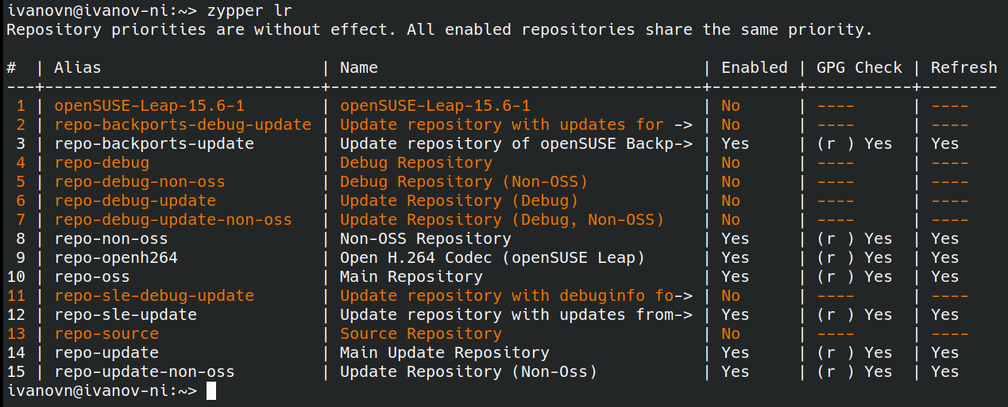
- Enable and set to auto-refresh the repo-update and repo-update-non-oss repositories

Task 02

- Perform system update
- Guide to performing system update: https://en.opensuse.org/System_Updates

Task 03

- Learn to use zypper as well as YaST software management to manage system/user software
  - Guide to using YaST software management: https://en.opensuse.org/YaST_Software_Management
  - Guide to using zypper: https://en.opensuse.org/SDB:Zypper_usage_11.3
- Remove nano and tree
- Install nano and tree:
  - nano (with YaST software management)
  - tree (with zypper)

Submission:

Take the screenshots of your work as requested below and submit this completed document to the dropbox on D2L:

1. Terminal window showing the hostname and the output of the “zypper lr” command. This screenshot should be taken after you enabled and set to auto-refresh the repo-source and repo-source-non-oss repositories:

replace the sample screenshot with your own screenshot:

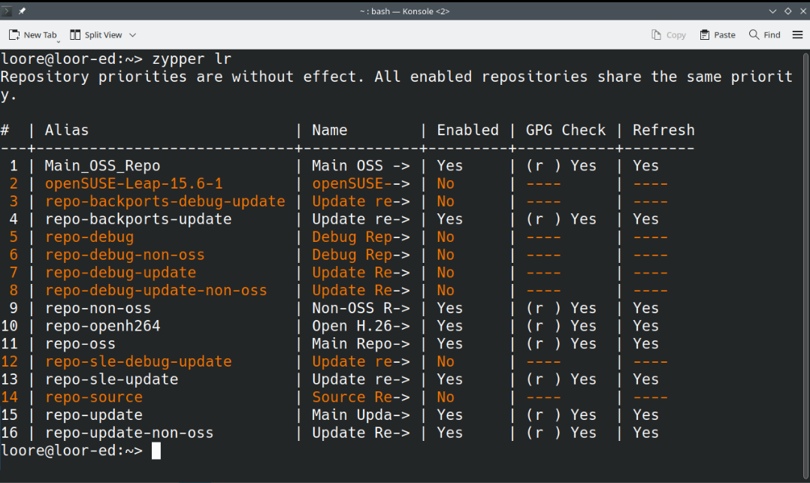

2. Terminal window showing the hostname and the output of the “zypper up” command. This screenshot should be taken after you fully update your Linux installation:

replace the sample screenshot with your own screenshot:

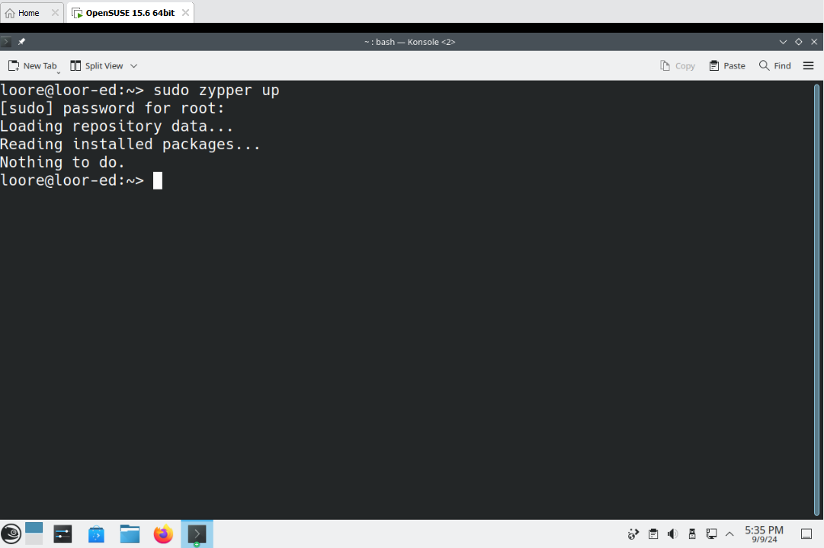

3. Terminal window showing the hostname and the output of the “nano” and “tree” commands. This screenshot should be taken after you removed “nano” and “tree” from Linux:

replace the sample screenshot with your own screenshot:

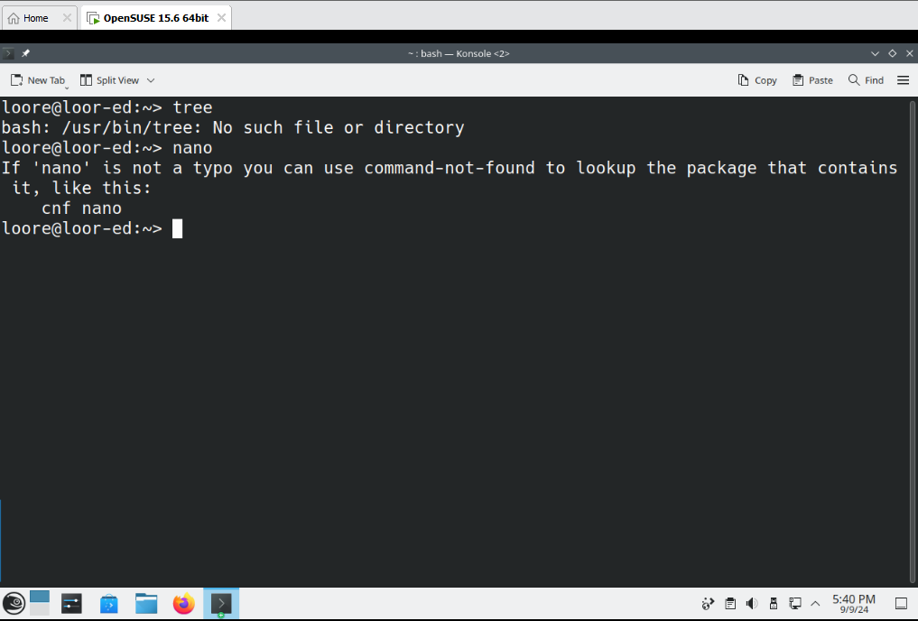

4. Terminal window showing the hostname and the output of the “nano” and “tree” commands. This screenshot should be taken after you install “nano” and “tree”:

replace the sample screenshot with your own screenshot:

